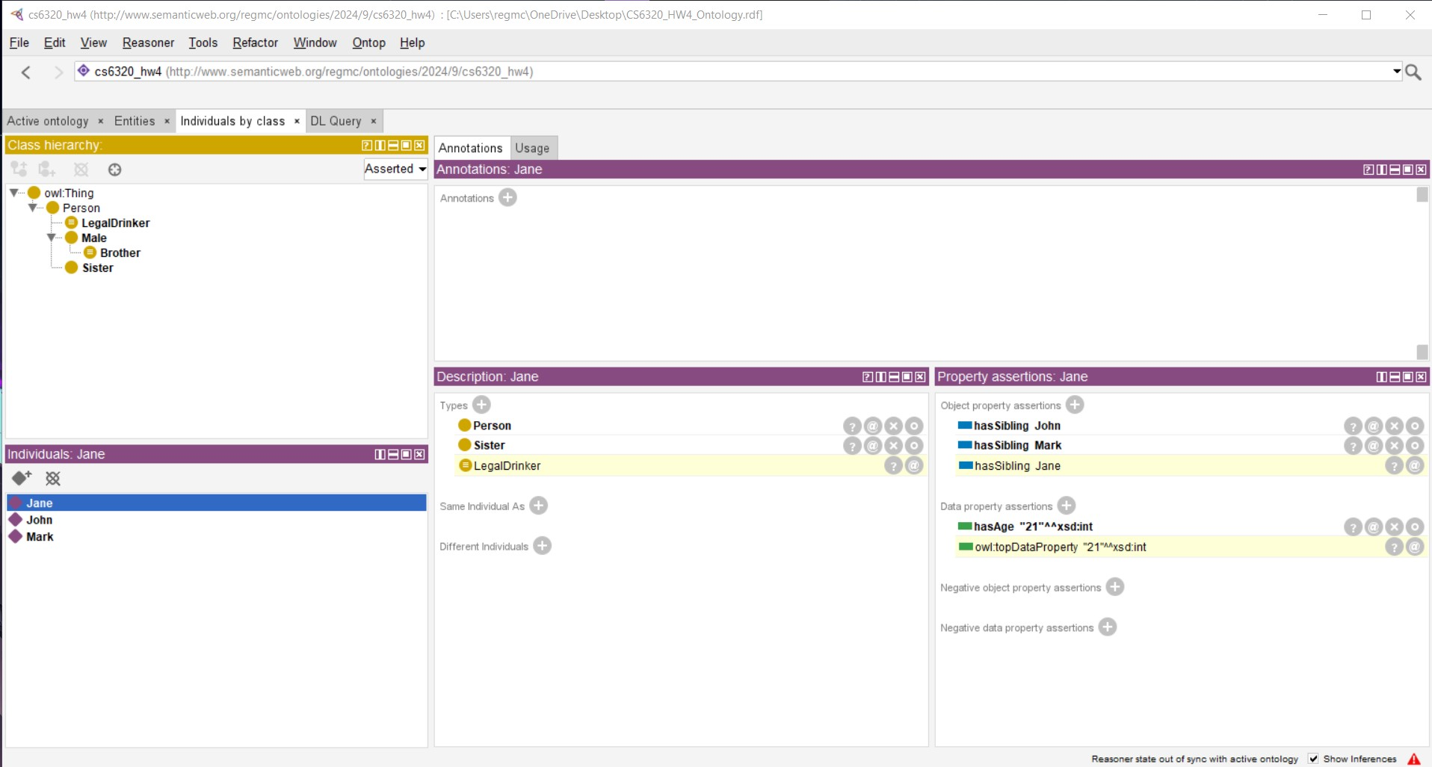
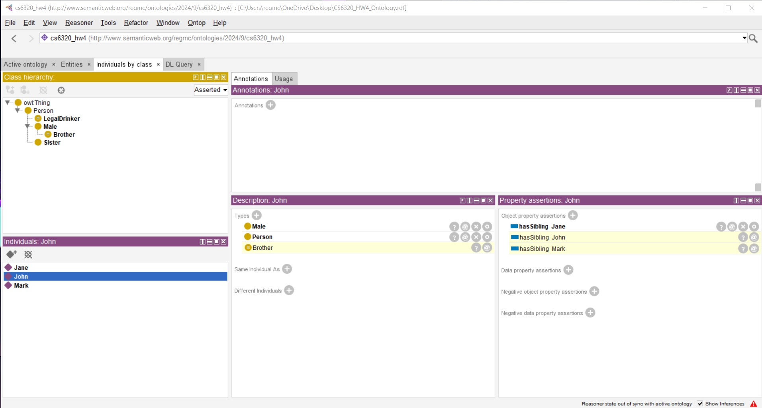
Problem 1.
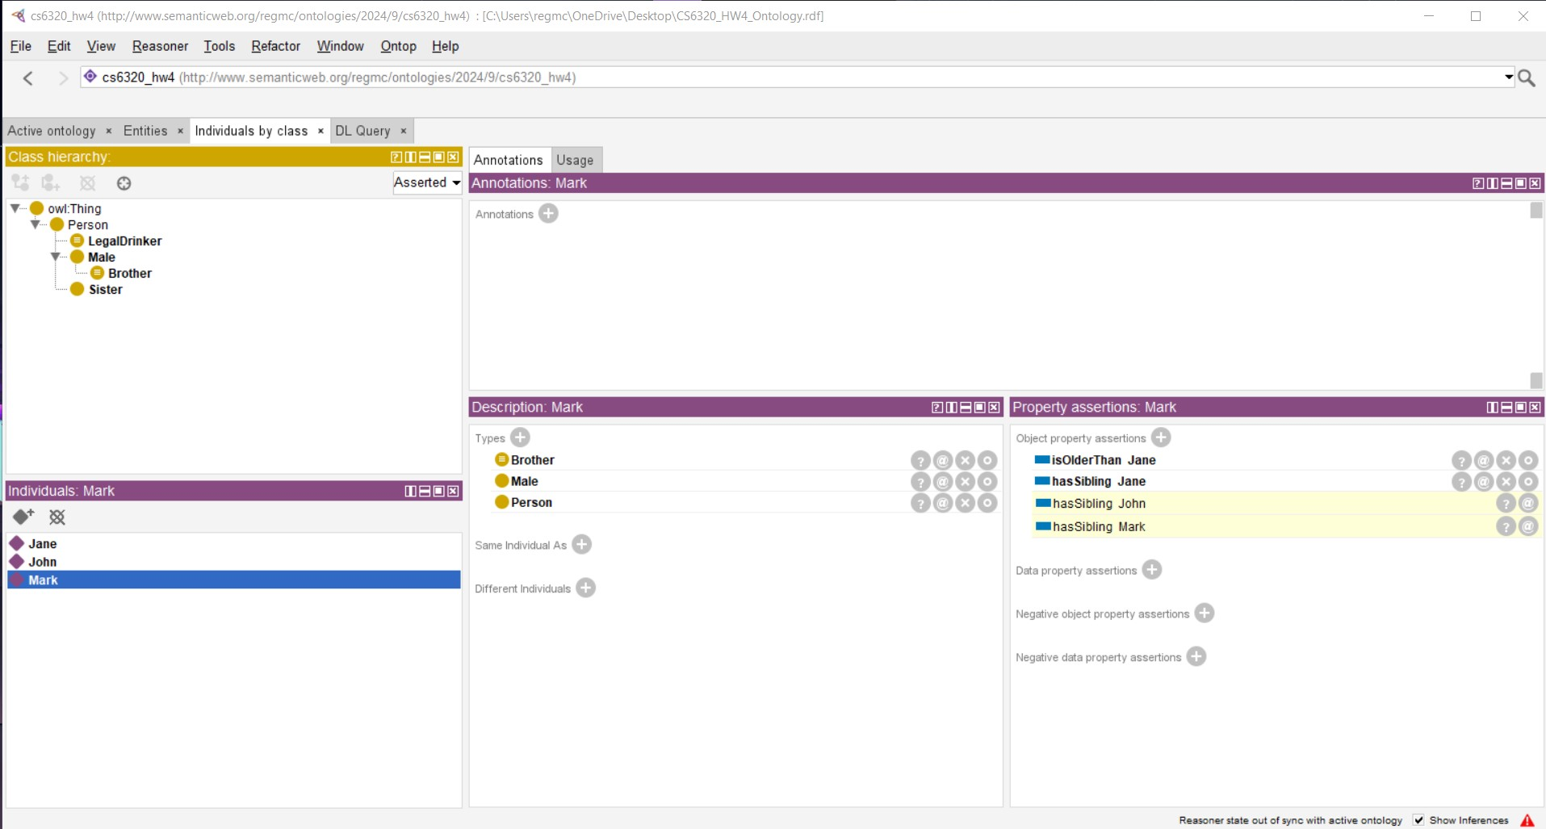

Problem 2.
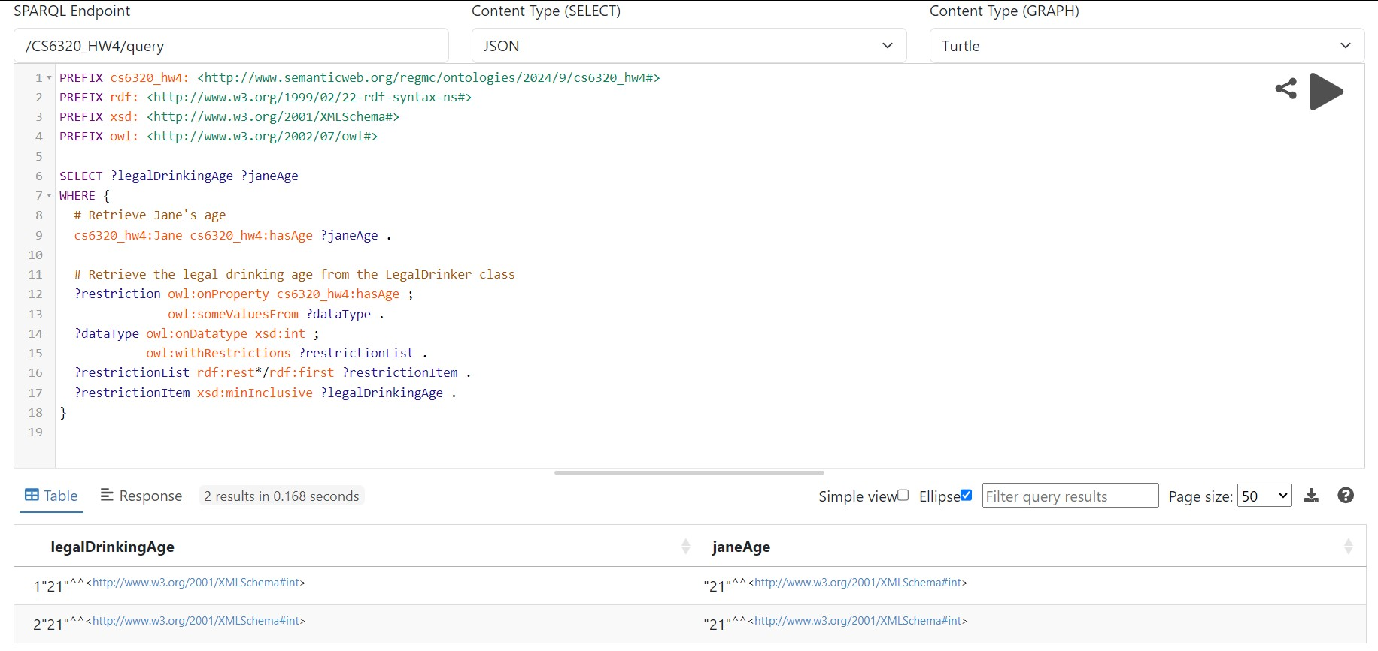
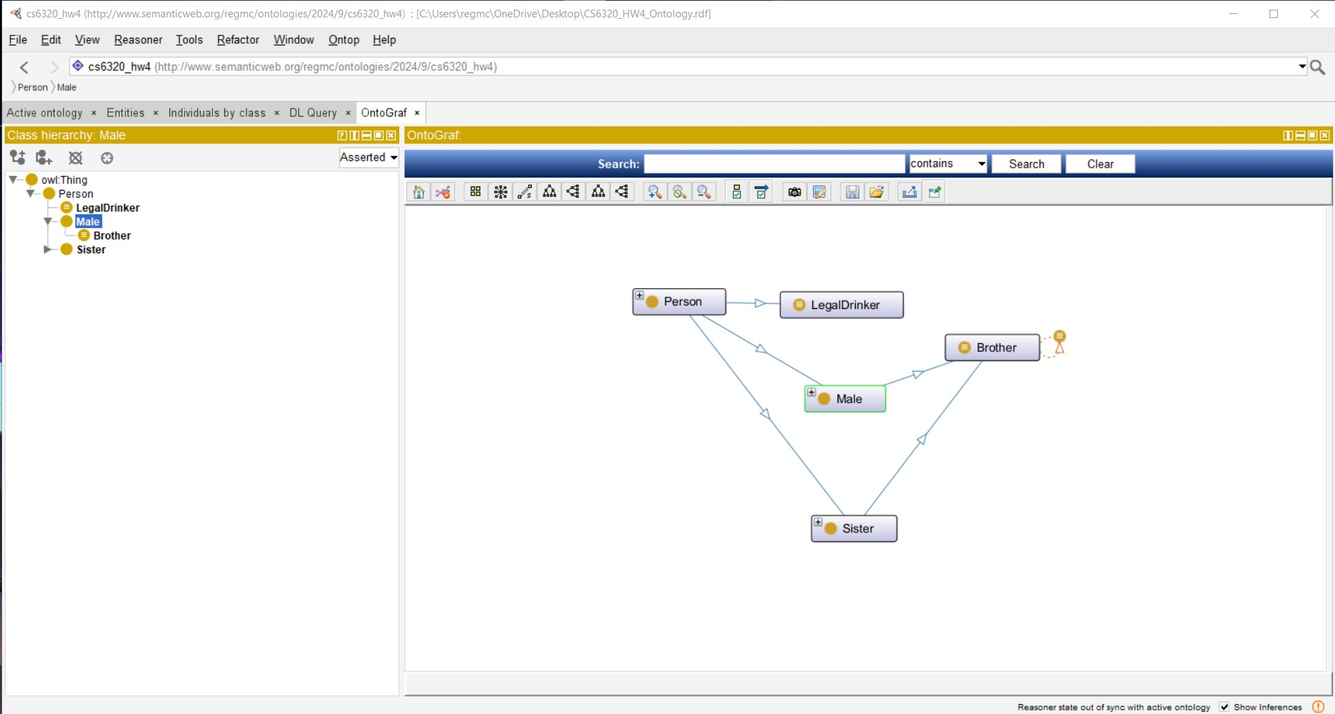

Problem 3.
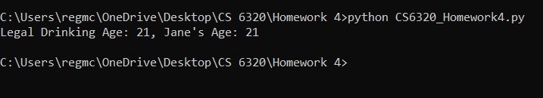

Explanation of screenshots

Problem 1:
The screenshots for Problem 1 show the class hierarchy as well as the individuals created based on the story in the problem description. The hierarchy has 3 classes: LegalDrinker, Male, and Sister; there is also a subclass in Male for Brother.

The first screenshot shows Jane. She was explicitly put in the Person and Sister class and had the object properties “hasSibling John” and “hasSibling Mark.” She also had the data property “hasAge 21.” These classes and properties were explicitly given to her based on the story from the problem description. The additional yellow classes and properties are ones that the reasoner inferred based on the axioms I created.

The next two screenshots show the same thing, except instead of Jane, it’s John and Mark respectively. Again, you can see the classes they’re in, as well as the object and data properties given to them. Likewise, you can see what the reasoner inferred based on my axioms.

Problem 2:
The first screenshot shows a graph visualized for the class hierarchy I made. The second screenshot is taken from Apache Fuseki and shows my SPARQL query and its output. The query is essentially asking “What is the legal drinking age and what is Jane’s age?”.

Problem 3:
This screenshot shows the output of a Python file called CS6320_Homework4.py that runs the same SPARQL query as problem 2—this time using the rdflib library.

